Don’t leave drill bits in chucks, put them up when done. | 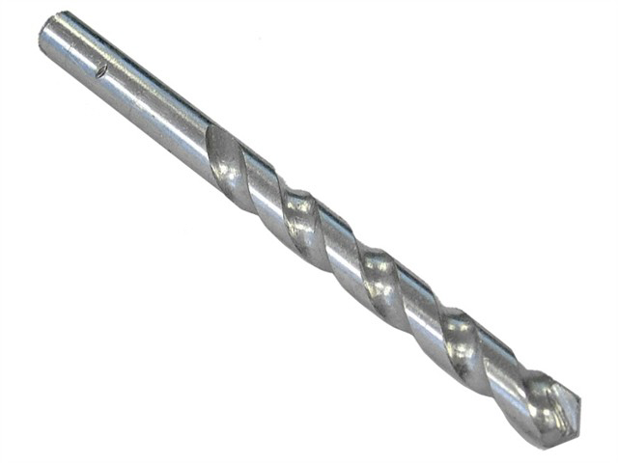
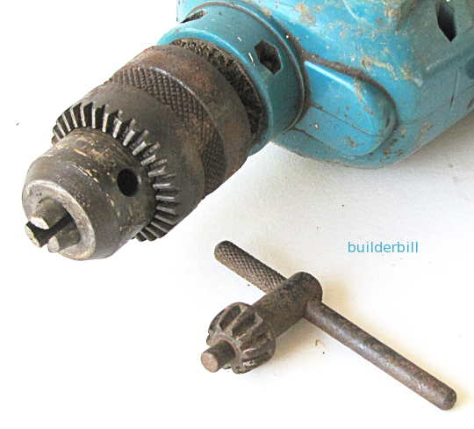 | Keep chuck keys with the tool it belongs to.

